**Operating System**

**Report**

**Assignment Simulation**

**Based**

**3rd Question**

**Student Name:-**Rathor Mukeshkumar

**Section:-**EE034

**Roll Number:-**B-45

**Email Address:-**mukeshrathodm999@gmail.com

**Github Link:-** <https://rathor-830.github.io/Assignment/>

**Que.3** Consider a scheduler which schedules the job by considering the arrival time of the processes where arrival time if given as 0 is discarded or displayed as error. The scheduler implements the shortest job first scheduling policy, but checks the queue of the processes after every process terminates and time taken for checking and arranging the process according to the shortest job is 2-time unit. Compute the waiting time, turnaround time and average waiting time and turnaround time of the processes. Also compute the total time taken by the processor to compute all the jobs.

**The inputs for the number of requirements, arrival time and burst time should be provided by the user.**

Consider the following units for reference.

Process Arrival time Burst Time

1 0 6

2 3 2

3 5 1

4 9 7

5 10 5

6 12 3

7 14 4

8 16 5

9 17 7

10 19 2

**Solution:-**

**Code for the Burst Time:-**

#include<stdio.h>

#include<conio.h>

int main()

{

int bt[10],p[10],n,temp,i,j,wt[10],sum=0;

float avg;

printf("Enter total no of proces:");

scanf("%d",&n);

printf("\n Enter burst time for each process:-");

for(i=0;i<n;i++)

{

printf("\nBurst time of process P%d:",i);

scanf("%d",&bt[i]);

p[i]=i;

}

for(i=0;i<n-1;i++)

{

for(j=i+1;j<n;j++)

{

if(bt[i]>bt[j])

{

temp=bt[i];

bt[i]=bt[j];

bt[j]=temp;

temp=p[i];

p[i]=p[j];

p[j]=temp;

}

}

}

wt[0]=0;

for(i=1;i<n;i++)

{

wt[i]=wt[i-1]+bt[i-1];

}

for(i=0;i<n;i++)

{

sum+=wt[i];

}

avg=(float)sum/n;

printf("\n Waiting time for each process:-");

for(i=0;i<n;i++)

{

printf("\n Waiting time for process P%d is %d sec.",p[i],wt[i]);

}

printf("\n Average waiting time is %f sec.",avg);

getch();

return 0;

}

**Description:-**

**Burst Time:-**Time required by a process for CPU execution.

**Output:-**

**Test Case-1**

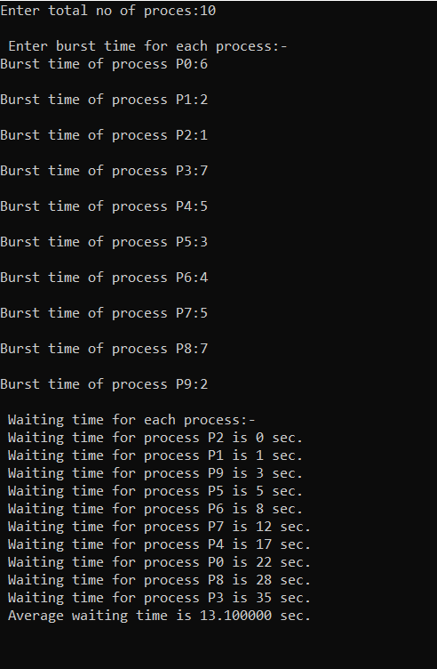

**Code for the Arrival Time:-**

#include<stdio.h>

#include<conio.h>

int main()

{

int bt[10],p[10],n,temp,i,j,wt[10],sum=0;

float avg;

printf("Enter total no of proces:");

scanf("%d",&n);

printf("\n Enter Arrival time for each process:-");

for(i=0;i<n;i++)

{

printf("\nArrival time of process P%d:",i);

scanf("%d",&bt[i]);

p[i]=i;

}

for(i=0;i<n-1;i++)

{

for(j=i+1;j<n;j++)

{

if(bt[i]>bt[j])

{

temp=bt[i];

bt[i]=bt[j];

bt[j]=temp;

temp=p[i];

p[i]=p[j];

p[j]=temp;

}

}

}

wt[0]=0;

for(i=1;i<n;i++)

{

wt[i]=wt[i-1]+bt[i-1];

}

for(i=0;i<n;i++)

{

sum+=wt[i];

}

avg=(float)sum/n;

printf("\n Waiting time for each process:-");

for(i=0;i<n;i++)

{

printf("\n Waiting time for process P%d is %d sec.",p[i],wt[i]);

}

printf("\n Average waiting time is %f sec.",avg);

getch();

return 0;

}

**Descrition:-**

**Arrival Time:-**Time at which the process arrives in the ready queue.

**Output:-**

**Test case-2**

